NOTICE OF JOINT REVIEW BOARD MEETING

CITY OF NORTH CHICAGO
SKOKIE HIGHWAY TAX INCREMENT FINANCING DISTRICT

Notice is hereby given to all interested parties that the City of North Chicago, Skokie Highway Tax Increment Financing District, Joint Review Board Annual Meeting will be held on Thursday, February 2, 2023 at 1:00 p.m. at City of North Chicago - Council Chambers located 1850 Lewis Avenue, North Chicago, IL 60064. Said meeting will be open to the public, and a copy of the agenda is attached.

CITY OF NORTH CHICAGO
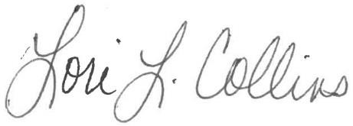
Lori Collins, City Clerk
AGENDA

CITY OF NORTH CHICAGO
SKOKIE HIGHWAY TAX INCREMENT FINANCING DISTRICT
JOINT REVIEW BOARD MEETING

Thursday, February 2, 2023
City of North Chicago - Council Chambers
1850 Lewis Avenue
North Chicago, IL 60064
1:00 p.m.

- Call Meeting to Order

- Roll Call of Joint Review Board Members

Member Representative / Signature

Lake County __________________________

Shields Township __________________________

North Chicago Community Unit School District 187 __________________________

College of Lake County - Community College District 532 __________________________

Foss Park District __________________________

City of North Chicago __________________________

Public Member __________________________

- Approval of Meeting Minutes - September 10, 2021

- Overview of Annual Financial Report for FY2021 City of North Chicago

- Overview of Project Activity City of North Chicago

- Joint Review Board Discussion

- Adjournment

